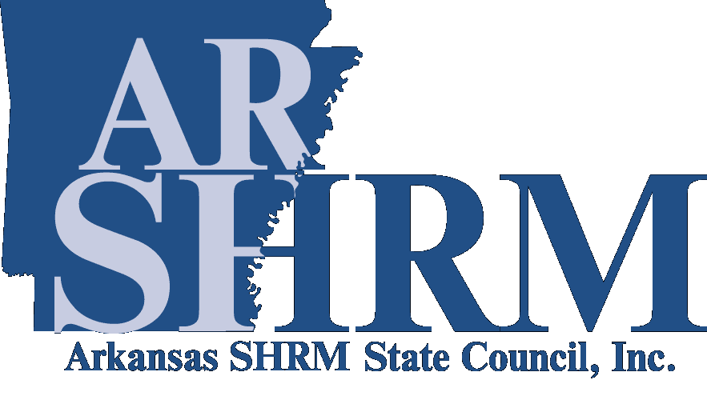
Arkansas SHRM State Council
Jim Wilkins Lifetime Achievement Award Nomination Form

Thank you for your interest in nominating a member for the Arkansas SHRM State Council Jim Wilkins Lifetime Achievement Award. The purpose of the award is to recognize an individual that has continually shown outstanding service and has promoted the profession of the Human Resources Management throughout their career. Nominees must be an active member of the Society for Human Resources Management. A list of previous winners is available at https://www.arshrm.com/recognizing-hr-leaders_id38.html

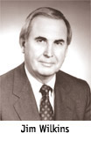
The award was created in honor of Jim Wilkins, who served as SHRM Area IV Manager for five years. During those years, Jim’s dedication, hard work and enthusiasm served as an excellent example for all human resource professionals to follow. His contributions to the profession and the lives he touched along the way provided the inspiration for the establishment of this award.

To be eligible for consideration, your original application must be received no later than SEPTEMBER 15. Emailed applications will be accepted. If you have additional questions, please do not hesitate to contact the ARSHRM State Council’s Communication & Awards Chair.

Email the original application to:
Arkansas SHRM State Council Communication & Awards Chair
Email: communications@ARSHRM.com

Application Criteria
Individuals nominated for this prestigious award will be evaluated on four major areas:
- Honestly, leadership, commitment, competence, integrity and moral strength.
- Vision for moving the field of Human Resources forward.
- Project and/or program success that have benefited the profession and HR professionals.
- Contributions to the profession that truly stand out.

Judging
A panel of judges will select the ARSHRM State Council Jim Wilkins Lifetime Achievement recipient. The panel will consist of the current SHRM members from within the state of Arkansas as approved by the state council. The application process and recipient selection are overseen by the ARSHRM State Council’s Communication & Awards Chair.
Each judge will review and rate the applicant on a scale from 1 to 10 with “1” being the lowest marks for that criterion, and “10” being the highest. The winner of the ARSHRM State Council Jim Wilkins Lifetime Achievement Award will be the applicant with the highest cumulative point total. If nominees do not meet the criteria as outlined or if no nominations are received, no award will be presented. Only one award will be given each year.

Please complete the following information as it relates to the Nominee:

Nominee’s Name:
HRCI Certification: | PHR SPHR GPHR Other:
SHRM Certification: | SHRM-CP SHRM-SCP
Nominee’s Company Name:
Nominee’s Title/Position:
Company Address:
Company Phone Number:
Type of Industry:
Size of Organization:
Nominator’s Name:
Nominator’s Company Name:
Nominator’s Title/Position:
Nominator’s Address:
Nominator’s Phone Number:

Please submit a detailed narrative summary (2000 word limit) outlining the nominee’s accomplishments in the Human Resources profession. The nomination may be submitted by an individual member, a chapter, a committee or the State Council. Videotapes, cassettes or CD’s will not be considered. In addition, Arkansas SHRM chapter recognition materials may be submitted for consideration.

Attach additional sheets as needed:

