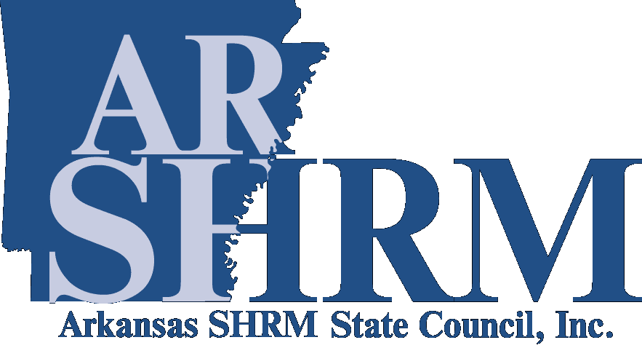
Arkansas SHRM State Council Human Resources Best Practices Award Nomination Form

Thank you for your interest in nominating an Arkansas organization for the Arkansas SHRM State Council Human Resources Best Practices Award. The purpose of this award is to recognize an organization that aligns successful HR programs and practices with the company’s business objectives. A list of previous winners is available at https://www.arshrm.com/recognizing-hr-leaders_id38.html

To be eligible for consideration, your original application must be received no later than SEPTEMBER 15. Emailed applications will be accepted. If you have additional questions, please do not hesitate to contact the ARSHRM State Council’s Communication & Awards Chair.

Email the original application to:
Arkansas SHRM State Council Communication & Awards Chair
Email: communications@ARSHRM.com

Application Criteria
A panel of judges will rate each application on the following criteria:
- The use of creativity in the development and design of the Best Practice.
- How well the Best Practice aligned with the Company’s overall mission.
- Recognizable and measurable positive outcomes, such as, increased level of customer satisfaction, reduction in turnover, etc.
- Value added through process improvements.

Judging
A panel of judges will select the ARSHRM State Council Human Resources Best Practices Award recipient. The panel will consist of the current SHRM members from within the state of Arkansas as approved by the state council. The application process and recipient selection are overseen by the ARSHRM State Council’s Communication & Awards Chair.

Each judge will review and rate the applicant on a scale from 1 to 10 with “1” being the lowest marks for that criterion, and “10” being the highest. The winner of the ARSHRM State Council Human Resources Best Practices Award will be the applicant with the highest cumulative point total. If nominees do not meet the criteria as outlined or if no nominations are received, no award will be presented. Only one award will be given each year.

Please complete the following information as it relates to the Nominee:

Company Name:
Company Address:
Company Phone Number:
Type of Industry:
Size of Organization:
Nominator’s Name:
Nominator’s Company Name:
Nominator’s Title/Position:
Nominator’s Address:
Nominator’s Phone Number:

Please include the following information as it relates to the nominee:

- Describe the design and development of the best practice.
- Describe how the practice aligned with the Company’s business objectives.
- Explain recognizable and measurable outcomes.
- Explain how the best practice added value through process improvements.

Attach additional sheets as needed:

