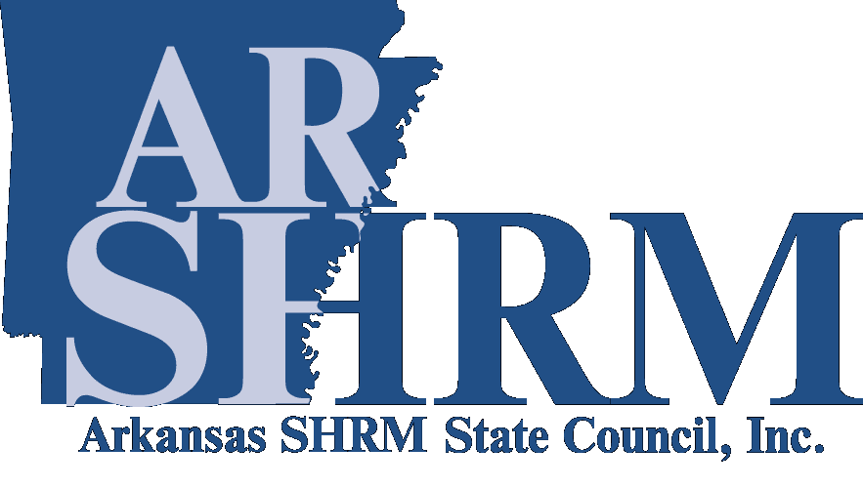
Arkansas SHRM State Council
Friend of the Human Resources Profession
Nomination Form

Thank you for your interest in nominating a member for the Arkansas SHRM State Council Friend of the Human Resources Profession Award. The purpose of the award is to recognize and express appreciation to legislative or business leadership who have proven a continued willingness and effort to listen to HR Professionals’ concerns relating to local, state and federal legislative matters affecting the profession. A list of previous winners is available at https://www.arshrm.com/recognizing-hr-leaders_id38.html.

To be eligible for consideration, your original application must be received no later than March 15. Emailed applications will be accepted. If you have additional questions, please do not hesitate to contact the ARSHRM State Council’s Communication & Awards Chair. This award is presented at the ARSHRM Employment Law & Legislative Affairs (ELLA) Conference held in the Fall.

Email the original application to:
Arkansas SHRM State Council Communication & Awards Chair
Email: communications@ARSHRM.com

Application Criteria
Nominees must have a record of accessibility and willingness to listen and learn about local, state or federal legislative issues affecting the Human Resources profession. This can include legislators, business leaders, organizations, or associations. This can also include associations, individuals or groups that have worked cooperatively with ARSHRM State Council on its legislative issues. Characteristics of the Award Recipient(s) may include:
- Proven him/herself/itself accessible to the Human Resources Profession relating to legislative activities or issues that advancing and promoting the Profession or could have an adverse impact on the Profession.
- Participates in educating the Human Resources Profession on legislative issues or is open to learning about legislative issues affecting the Profession.
- Provides support, directly or indirectly, to ARSHRM legislative goals.
- Consistently serves as a resource to HR Professionals who are engaged in the legislative process.

Judging
A panel of judges will select the HR Friend of the Human Resources recipient. The panel will consist of the current SHRM members from within the state of Arkansas as approved by the state council. The application process and recipient selection are overseen by the ARSHRM State Council’s Communication & Awards Chair.

Each judge will review and rate the applicant on a scale from 1 to 10 with “1” being the lowest marks for that criterion, and “10” being the highest. The winner of the HR Friend of the Human Resources Profession Award will be the applicant with the highest cumulative point total. If nominees do not meet the criteria as outlined or if no nominations are received, no award will be presented. Only one award will be given each year.
Please complete the following information as it relates to the Nominee:

Nominee’s Company Name:
Company Address:
Company Phone Number:
Type of Industry:
Size of Organization:
Nominator’s Name:
Nominator’s Company Name:
Nominator’s Title/Position:
Nominator’s Address:
Nominator’s Phone Number:

Please submit a detailed narrative summary (2000 word limit) outlining the nominee’s accomplishments for the Friend of the HR Profession Award. The nomination may be submitted by an individual member, a chapter, a committee, or the State Council. Electronic recordings will not be considered.

Attach additional sheets as needed:

